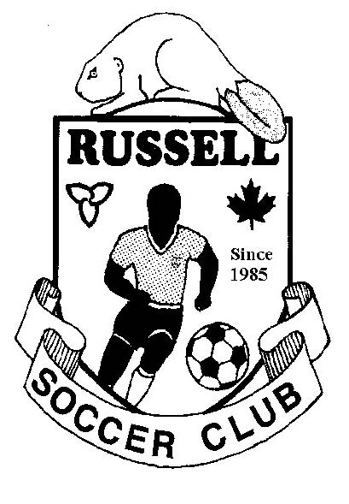

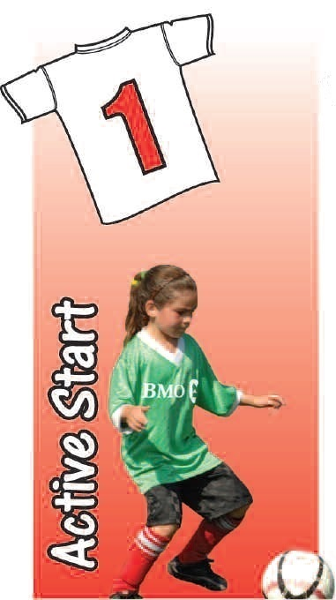 | House League  Coach Manual  U4-U5 Age Group  Active Start  May 2016

TABLE OF CONTENTS

INTRODUCTION 2
THE ACTIVE START 1–TO-1 SOCCER PROGRAM ~ WHAT IS IT? 3
THE ROLE OF THE PARENT / PLAYING PARTNER 4
UNDERSTANDING THE 4 and 5 YEAR OLD SOCCER PLAYER 5
THE TYPICAL SESSION 7
RUNNING WITH THE BALL / DRIBBLING 8
KICKING THE BALL & SHOOTING 11

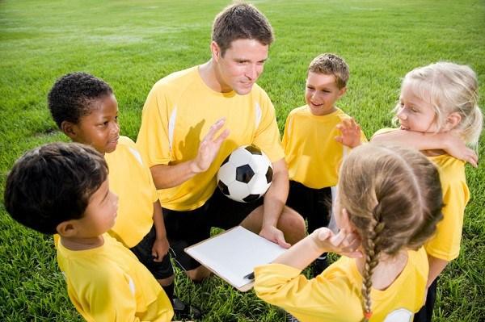
INTRODUCTION

Welcome to the World of 4 and 5 year old Soccer!
To assist in your participation in the upcoming “season”, and in your new role as a Parent-Coach, the Club is pleased to provide you with a copy of the Club’s 1:1 Parent-Coach’s Guide. We hope it contributes to you and your child having a great first experience in soccer!
In this guide you will find the unique characteristics of 4 and 5 year old soccer (individualistic play), the focus of skill development at this age (running with the ball/dribbling and kicking/shooting) as well as the key technical components, coaching elements and suggested activities for each.

Thanks again for your commitment and dedication to our community by coaching and providing our kids with the opportunity to play this great game.

Yours in soccer,

Robert Taylor  Club Head Coach  russellheadcoach@hotmail.com | Pat Hunter  Club President  patrick.hunter7@hotmail.com

Club Email – rsclub@russellsoccer.com

THE ACTIVE START 1–TO-1 SOCCER PROGRAM ~ WHAT IS IT?

- The 1-to-1 Soccer Program is an introductory program for children aged 4 and 5, and their parents, to participate in the activity of soccer in a safe and fun environment.
- Registered children must have a parent (or playing partner over the age of 16) who will participate in the sessions, hence the name 1-to-1.
- Parents with soccer and coaching experience are encouraged to step forward and to offer assistance with leadership/coaching duties.
- Players will learn some basic skills of the game, focusing primarily on running with the ball, through a series of fun activities and games that are delivered by volunteer Leaders and that rely upon the involvement of each player’s parent who serve as a Parent-Coach.
- Each player will receive a Russell Soccer League (RSL) uniform and a ball.
- Weekly sessions begin in May and end with the awarding of participation medals at the year-end soccer festival in July.

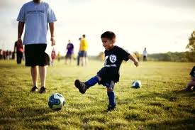
THE ROLE OF THE PARENT / PLAYING PARTNER

The focus of the 1-to-1 Program is to encourage a love of soccer and to assist in initiating the players to some movement skills as well as basic soccer skills like running with the ball and kicking.

Parents are asked to serve as Parent-Coaches, with their primary role being a leader and practice partner for their child; if a parent is not available, a mature playing partner aged 16 or over works too.

Parents are not required to know anything about the game of soccer, but your participation is essential to having a successful and fun experience for your child.

Parents are encouraged to review the various activities and games that are described in this Guide in order to make their “job” easier on practice night; being familiar with the organization of the most common activities will make your involvement in the activities that much easier and will provide the opportunity for quicker transitions between the instruction & demonstration of the Leaders and the actual practice opportunity for your child.

Parents are encouraged to play soccer with their kids in the backyard or at the park, using the Guide as a reference for some fun games.

By reviewing the Guide, the Parent-Coach will know the Key Factors and basic technical elements to share with their child and to assist in their enjoyment and development.

In addition to making sure their child is properly dressed with their uniform and shin pads (optional), parents are responsible for ensuring that their child brings their ball to practice (which is provided by the Club).

Although we’re not expecting parents to have the most expensive soccer shoes or track-suit, we do encourage everyone to be dressed appropriately for some mild activity.

Being on time and letting the Leaders know when your child will not be able to attend is appreciated; although “life” can get in the way of being on time on occasion, and understanding that 100% participation isn’t a requirement of the Program, the organization and coordination of a large group of four-year olds relies heavily on knowing how many kids can be expected for each session and that everyone arrives on time.

Enthusiasm is contagious; if you show an interest and have an excitement towards the game, your child and those around him/her will likely do the same.

UNDERSTANDING THE 4 AND 5 YEAR OLD SOCCER PLAYER

First and foremost, we wish to develop a love for the activity of soccer in each child. To ensure we are successful in this endeavor, we must remind ourselves of the characteristics of the four-five year old player and tailor our interaction with them accordingly. For instance:

- Players are very individualistic and self-oriented at this age so individual activities must be emphasized over team activities or those that require waiting their turn, passing or sharing.
- This is why each player needs a ball and a parent-coach on the field.
- Small-sided games or activities that require traditional teamwork are at best a challenge and, at worst, impossible.

More detailed information on the unique requirements of 4-5 year old soccer player can be found below:

Characteristic | Implication ~ Coaching Tips
Short attention spans. | Keep instructions short and simple with no more than 3 pieces of information at a time, delivered in less than 30 seconds.
Limited and / or selective attention. | Minimize distractions, particularly when speaking with them (ex. don’t have the players face the sun when speaking to them, and don’t let them see their ‘freezies’ before the end of practice).  And if a grasshopper happens to grab the attention of the kids, stop what you’re doing and go have a look.
Limited cognitive abilities and memory, which lead to an inability to understand certain concepts or to remember things for more than a short period of time. | The idea of playing within the lines of the field or in a defined area may take some time. Be patient and laugh when they forget instructions like boundaries or what direction they were supposed to run.  Have quick transitions from instruction to practice. Keep it simple and keep it fun.
Self-image is developed and affected through interaction with others. | Be generous with praise. Use positive language that focuses on what they need to do as opposed to negative language that focuses on what they shouldn’t do.  Find the positive in every attempt and catch them doing the right things.
Kids prefer “parallel play”, meaning they will play on a team but not really interact or engage their teammates; evidenced by the inability or refusal to pass the ball. | Individual enjoyment and skill development is the focus. Small-sided games or activities that require traditional teamwork are at best a challenge and, at worst, impossible. This is why running with the ball and individual ball activities are emphasized and why each player needs a parent on the field.
Gross motor skills are still being developed and coordination is limited. | Incorporate general movement activities like running, jumping, and tumbling that use the ball in some way (even if only to jump over or hold). Avoid activities requiring fine motor skills. Simple catching of the ball can be a challenge. We are not concerned about kids using their non-dominant foot.
Very self-oriented and inward focused. | Sharing is still a work-in-progress. Provide lots of opportunities to touch the ball and provide each child with their own ball.
They generally exhibit two speeds; all or nothing. | They are constantly in motion but with no sense of pace. They will run and chase something until they drop. They will tire easily, and even though they can recover quickly and go again, adequate water breaks need to be planned as their “cooling” systems are not as developed as older kids.
Even though boys and girls are relatively the same at this age, there can be a wide gap between individual kids’ chronological and developmental ages. | Your expectations and interaction can be the same for both genders. But we must remind ourselves that there can be as much as 24 months difference in developmental abilities across kids of this age and we must respect and accommodate for these differences.
They want to have fun. | Allow them to play without pressure.
They are physically small. | They will prefer a softer ball over a harder ball, and should use a size 3 ball.

THE TYPICAL SESSION

Each session will follow the same general format:
- Opening Group Activity : 5-10 minutes
- Circuit Training : 3 x 10-12 minutes
- Closing Group Activity : 5-10 minutes
- Post-Activity Snack

“Circuit Training” refers to splitting the larger group into 3 to 5 smaller groups in order to accommodate the large number of kids who register for the Program. Each smaller group will spend approximately 10-12 minutes at various stations during the session.
Although there are no formal games involving one team versus another team, from time-to-time, one of the stations will provide the opportunity to play a modified soccer “game”.
For the four year old player, the primary skill focus is on running with the ball (dribbling) and this skill will be incorporated into every session and most circuit stations.
A secondary focus is on kicking the ball, which will also be developed during the season. Also, since kids must first be able to control their own body before they can be expected to control the ball, fundamental movement skills will also be promoted and developed.
With both soccer skills, dribbling and kicking, a series of common drills and activities have been provided in this Guide. Preceding the drills and activities are a description of the Basic Technical Elements and Coaching Key Factors for each skill. Adapted from the Ontario Soccer Association, one of the common coaching techniques we follow is called Key Factor coaching. From the four-year old 1:1 player through to the fourteen-year old player on one of the Club’s Representative teams and on, we wish to provide consistent and properly sequenced instruction throughout a participants development as a soccer player. An underlying objective for all coaches in the Club is to provide a foundation of appreciation, skill and understanding of the game throughout a player’s time with the Club that will allow them the opportunity to participate at any level they desire as they grow older.
Of course, the focus with the four-year old player is to have fun while providing lots of opportunity to play with the ball and to learn the age appropriate FUNdamentals of both soccer and physical activity in general.
By providing the Basic Technical Elements and coaching Key Factors, we provide a common language and message from which to develop our kids. The Basic Technical Elements and Key Factors generally do not change as the age and level of the player increase; rather it is the progressions, variations, and expectations of coaches that will increase with the player’s age and ability.

RUNNING WITH THE BALL / DRIBBLING

Basic Technical Elements
- “Push” or “guide” the ball with your feet – don’t kick it and chase it
- Gently push the ball with the inside of the feet for closer control
- Gently push the ball with the top of the foot when dribbling for speed and into open space
- Keep the ball within reach (a stride or arms-length or two)
- Control first, speed second

Coaching Key Factors
- Primary Key Factors
  - Gently push the ball
  - Keep the ball within reach
  - See / watch the ball
  - See the field / look up

- Secondary Key Factors
  - Change of direction
  - Change of pace / speed
  - Skill (fakes & dekes)
  - Attack (the defender, the open space, or the goal)

Dribbling Activities
With a little creativity, almost every childhood game can be turned into a dribbling activity (tag, follow the leader, etc.). By incorporating dribbling into these familiar games, the amount of time needed to organize and teach kids the activity is greatly reduced and the introduction into this new skill is made easier. By involving kids in fun activities that provide the opportunity to work on the key factors, the game itself will be as much a teacher as any instruction we might provide.

Red-Light Green-Light
- Each player is standing along one end / touch line and has a ball
- The coach is 15-20 yards away along another line or just in open space
- The coach calls out “Green Light” to let the players know they can dribble towards the other end, and “Red Light” when they need to stop dribbling
- Players stop the ball by placing the sole / bottom of their foot on top of the ball
- The game ends when all players (or most) have made it all the way to the other end
- If a player kicks the ball too far forward or cannot stop the ball within a reasonable distance after you call “red light”, playfully tell them they need to back up (you may need to physically, yet playfully, move their ball back for them)
- You can also ask players to perform special FootSkills with the ball during the game as a progression. Ask players to rev their engine by performing “toe-taps” on the ball (where kids simply tap the top of their ball alternately with the bottom of each foot) or ask them to perform a “pull-back turn” (step on the top of the ball with the sole / bottom of the foot and pull the ball back under and behind them to start dribbling in the opposite direction)
- Play several rounds with the kids, making each round just slightly different; be creative!
Dribble-Stop by Body-Part
- Within a sufficient size area, players dribble their ball freely
- As the players dribble, the coach calls out a body part (knee or elbow or hand, etc), which each player must use to immediately stop the ball, and then they resume dribbling
- As a progression, the coach can encourage other skills as well, such as “pull back turn” or “5 toe taps” while the players dribble
- Could also ask players to switch balls … there’s all kinds of variations … be creative!

Cross the Castor River or Cross the Crocodiles
- The object of this game is to get from one side of the “river” to the other side without getting caught
- 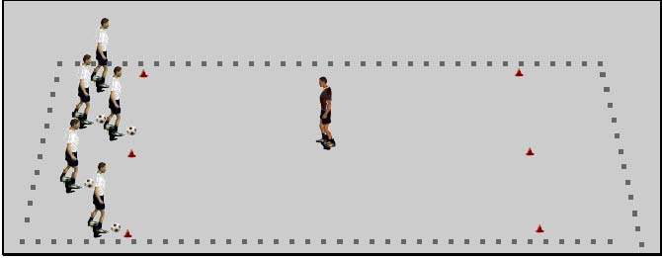
- Use cones to make two end zones that are about 5 yards deep and a sufficient size wide (the shores) and one larger middle zone (the river)
- One or more defenders / crocodiles will start in the middle zone (typically adults when the game is being introduced) and will try and “stop” the dribblers from getting from one end zone to the other end zone
- Every dribbler has a ball and starts at the same end, trying to dribble through the middle zone and by the defender(s) / crocodiles, and finally stopping their ball in the other end zone (players cannot simply kick and chase, which is why they must be able to stop the ball in the opposite end zone)
- Dribblers who don’t make it through the middle zone (because the defender / crocodile captured the ball with their feet) or who cannot stop the ball in the opposite end zone, become one of the defenders / crocodiles, until only a few players are left
- A variation is when the defender / crocodile becomes a dribbler when they capture someone’s ball, and the dribbler who lost their ball becomes the new defender / crocodile

Toilet Tag / Freeze Tag
- All the players are dribbling their ball within a sufficient size area
- At least two leaders are the “taggers” who the players are trying to avoid
- When a player is tagged in “toilet tag”, they must stop their ball and hold one arm straight out beside them; they can start dribbling again when one of their teammates “flushes” their arm
- When a player is tagged in “freeze tag”, they must “freeze” and hold their ball in the air (or some other variation); they can start dribbling again when one of their dribbling teammates tags them back to “unfreeze” them.
- A fun activity to try occasionally is having the players be the taggers and the coaches are the dribblers

Mirror Man / Window Woman
- Within a designated area of sufficient size, each player has a ball
- Ensure each player has sufficient space so as not to bump into each other (have them stretch their arms and hands out so they can’t touch anyone else)
- All players must “mirror” the movements of the coach who is standing where everyone can see them
- Encourage players to move left or right (by rolling the ball with the sole of the foot), backward (by pulling the ball with the sole of their foot), stop, turn, switch balls, etc
- You can also incorporate some FootSkills practice, like toe-taps
- You can also incorporate some fundamental body movements without the ball, like jumping over the ball, standing on one leg, etc.
- A similar game to play would be “Simon Says” and also “Follow the Leader”

Shark Tank or Dog Catcher
- Within a designated area (called the “water tank”), each child (the “fish”) dribbles a ball; the area must be large enough to accommodate all the players
- The fish must stay within the boundaries of the water tank
- At random intervals, introduce a “shark”, or multiple sharks, into the tank to chase the fish (a parent or coach chases the kids); the shark leaves the tank when it gets “tired”
- As a progression, the shark can gently kick the ball of a fish out of the tank if the ball isn’t under control, requiring the fish to quickly run out of the tank to get their ball and get back into the tank
- This is a great activity to teach kids how to dribble away from someone and also how to “shield” the ball away from someone (basically, keeping their body between the ball and the shark)
- A similar game is to have kids pretend they are walking a dog when they are dribbling (the ball is the dog), and a dog catcher (a parent or coach) comes into the area to try and catch the player’s dog

Fill the House or Thief
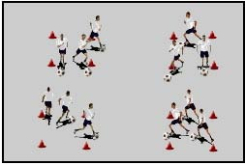
- Split your team into four equal groups where everyone has a soccer ball
- Make four small squares (houses) with cones
- Assign each group to one of the squares (houses)
- The object of the game is to dribble all the balls from your square (house) and put them into another team’s house; the team with the least number of balls in their house after 45-60 seconds is the winner
- Switch the team members as necessary
- Balls can be dribbled (with variations), or moved by hand (by hand is a good way to introduce the game to the younger players); in any event, be creative!
- A similar game is called “Thief” where the set-up is the same but instead of dribbling balls into someone else’s box, the object is to dribble all the balls into your box, and the group with the most balls wins; also, to start a game of “Thief”, the balls can start inside the squares or in the middle of the area

KICKING THE BALL & SHOOTING

Basic Technical Elements
- Watch the ball (from approach through contact)
- Non-kicking foot next to the ball at contact
- Non-kicking foot pointing at target
- Kick through the middle of the ball

Instep Kick / Shot
- Take a slightly angled approach to the ball
- Toes pointed down (foot extended) when kicking the ball
- Contact the ball with the laces / top of foot / instep (NO TOES)
- Contact the middle of the ball
- Follow through (for power)

Inside of Foot Kick / Shot
- Turn toe out and tighten ankle
- Contact ball with inside of foot
- Contact the middle of the ball

Coaching Key Factors
- accuracy before power
- eyes on ball / head steady
- part of foot to kick with (instep/laces or inside of foot)
- part of ball to kick (middle)

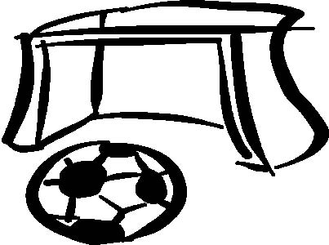
Shooting / Kicking Activities

Torpedos
- Split the players into two groups and have them form two lines that face each other and are 5-10 yards apart; parents should be behind their child and each child has a ball
- By walking (slowly & quickly) through the middle area between the two lines, the coach (the “ship”) tries to get from one end to the other
- The players kick their ball (“torpedo”) to try and hit the coach
- The coach can specify how many hits it takes to sink the “ship”, or simply play-it-up with respect to sinking as they go from one end to the other with each hit

Stingers or Stinger Bees
- Within a sufficient size area, each child is dribbling their ball while their parents are walking in the same area without a ball
- At the coaches command, the players turn into bees and pretend to sting the parents by kicking the ball at their legs
- Players try and see how many bee stings they can make

Knock-Over or Bowling
- By using a “tall” cone, or a ball that rests on top of a “flat” cone, the player kicks their ball from a reasonable distance and tries to knock over the cone or ball (that can be called a bowling pin)
- The parent stands behind the cone to retrieve the ball and to set up the cone after its knocked down
- As the player knocks the cone (or ball) somewhat consistently from a short distance, the distance can be increased

Kicks
- Each player and their parent, stand 5 yards apart
- A mini-goal made of two cones that are 3-5 feet apart separates them
- The player begins by kicking a stationary ball through the goal to their parent
- Progressions include the parent rolling the ball to their child and the child kicks the ball on their first-touch; or the player dribbles to the cones and kicks the moving ball through the goal and to their parent; etc

Tunnels
- Each player dribbles a ball within a sufficient size area
- The parent partner, who doesn’t have a ball, move about the area with the players
- On the coach’s command (“tunnel’s open”), the adults stop and spread their legs to form a tunnel
- The players must dribble towards an adult and shoot through the tunnel
- Allow enough “tunnel” time to have each player kick through a tunnel; and players can try and kick through more than one tunnel while the tunnels are open
- On the coach’s command (“tunnel’s closed”), the adults start moving about the area again
- As an alternate way of organizing “Tunnels”, you can have the kids dribble along the outside of a big square marked by cones with all the parents on the inside of the square; the coach leads the kids along the perimeter of the square, and once all the kids are on a single side, the coach calls “Tunnels” and the kids dribble through the middle of the square and kick through the “Tunnel” of a parent to the other side of the square.

For any of the activities in this Guide, feel free to personalize them in your own way.

The instructions are like guidelines, and although each activity is ‘tried & tested’,
there are a variety of ways and modifications that can be made when leading these activities.

BE CREATIVE!

